**HAPTER III  
PROBLEM ANALYSIS**

**III.1 . Intel Compute Stick External Features**

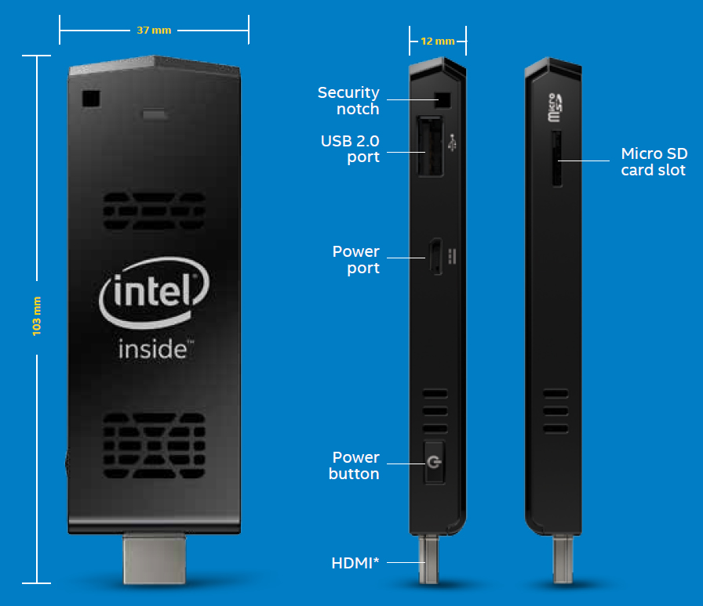

**Figure 3.1 Intel Compute Stick External Feature (REF :** [**http://www.tomshardware.com/reviews/intel-compute-stick,4126.html)**](http://www.tomshardware.com/reviews/intel-compute-stick,4126.html))

The power button is awkwardly placed on the side of the Compute Stick, near the HDMI connector. Hopefully, later versions can fix its placement. Whenever we were unplugging or adjusting the device, we had to be careful not to accidentally press down on the power button when grabbing hold of it.

For power, the Compute Stick comes with a 3 foot power cable that plugs into the unit's power port on one end and a USB connector that plugs in the 5V plug on the other.

For physical security, the Compute Stick doesn't use a conventional Kensington security slot. Instead, it uses a couple of connecting notches on the upper corner of the case. To secure it, a thin metal cable would be inserted into one side of the Compute Stick and out the other. More of an industrial type of physical security, the cable could then be crimped down to lock the product.

**III.2. Intel Compute Stick Internal Features**

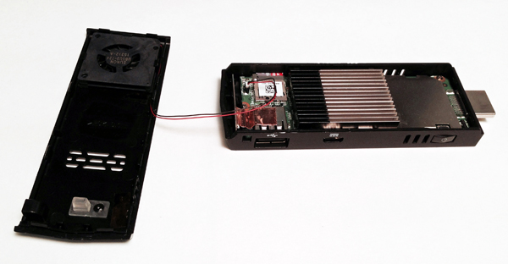

**Figure 3.2 Intel Compute Stick Internal Feature (REF :** [**http://www.tomshardware.com/reviews/intel-compute-stick,4126.html)**](http://www.tomshardware.com/reviews/intel-compute-stick,4126.html))

From Intel's Bay Trail family of SoCs, the Compute Stick sports Intel's quad-core Atom Z3735F processor. Launched in early 2014, this 64-bit SoC sports 2 MB L2 cache and runs at a base frequency of 1.33 GHz (1.83 GHz in burst). Memory-wise, the Compute Stick uses single channel DDR3L running at 1333 MHz, which is limited to 2 GB of RAM due to the constraints of the Atom processor.

For graphics, the Compute Stick is powered by Intel's HD Graphics, which is integrated in the Atom Z3735F processor. Using Intel HD Graphics Control Panel, consumers can adjust common display settings, manage power settings and create custom profiles that let you save video settings for different environments or lighting situations.

**III.3. Intel Compute Stick Diagram Block**



**Figure 3.2 Intel Compute Stick Diagram Block (REF :**  [**https://downloadmirror.intel.com/24987/eng/STCK1A32WFC-STCK1A32FC-STCK1A8LFC-TechProdSpec01.pdf)**](%20https://downloadmirror.intel.com/24987/eng/STCK1A32WFC-STCK1A32FC-STCK1A8LFC-TechProdSpec01.pdf))

**III.3. Intel Compute Stick Spesifications**

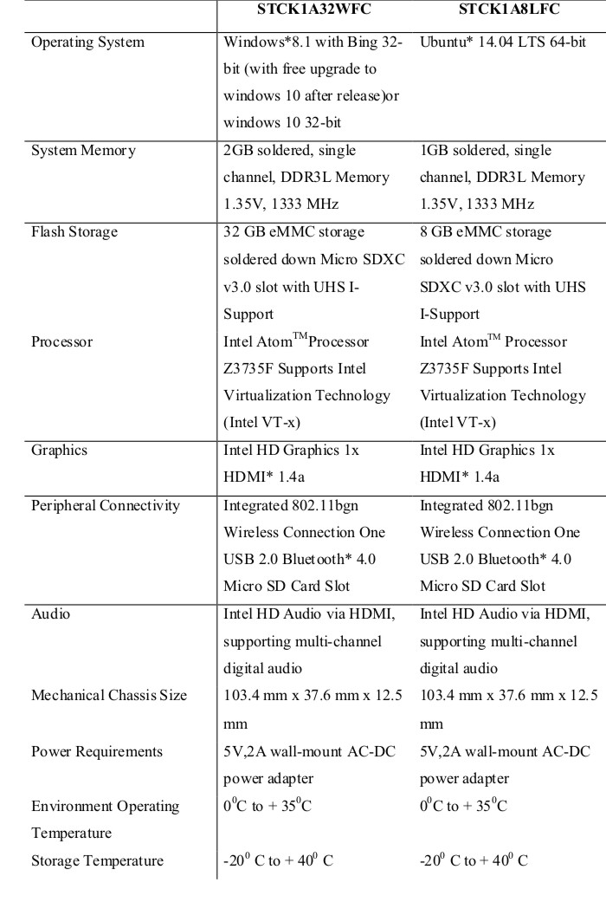

**Figure 3.3 Intel Compute Stick Spesifications (REF :** [**http://www.tomshardware.com/reviews/intel-compute-stick,4126.html)**](http://www.tomshardware.com/reviews/intel-compute-stick,4126.html))

**III.4. Intel Compute Stick Usage**

One of the first things we wanted to check out about the Compute Stick was how it handles web video. Surprisingly, watching movies and shows on Netflix and Hulu was a great experience and YouTube videos played with no delay. The streaming was smooth and the Compute Stick's built in sound, coming out of the TV, was clear. When video was playing using Netflix it did produce some lag as you moved the mouse across the screen, yet there was no effect on the streaming content as it played. This is usually a problem when the mouse is used further out than 10 feet, which is somewhat expected. However, we were only about eight feet away from our office's 54 inch LCD when this happened.

We also tried to use Remote Desktop on the Compute Stick and tried to connect to a computer over Wi-Fi. Initially, we ran into some delay as the Compute Stick connected and logged into the PC for the first time. We typically don't see such a lag when using Remote Desktop, but taking into account that the Compute Stick's Wi-Fi isn't 802.11ac, and that we're working with an SoC, running a Remote Desktop session may be more than the Compute Stick could initially handle. The load time did improve after the first session and we also saw similar response times using a 802.11ac USB NIC on the Compute Stick.

**III.5. Intel Compute Stick Box Contents**

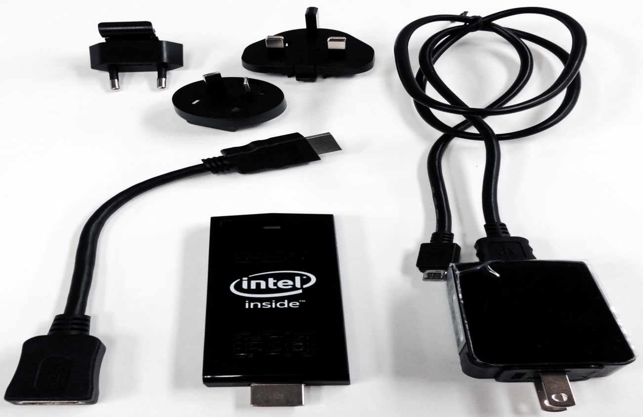

## Figure 3.4 Intel Compute Stick Box Contents(REF : <http://www.tomshardware.com/reviews/intel-compute-stick,4126.html>)

The sample kit that Tom's Hardware received for testing included the following:

1. Intel Compute Stick pre-loaded with Windows 8.1 with Bing 32-bit;
2. 5V, 2A wall mount USB AC-DC power adapter;
3. 3 inch USB cable for the power adapter;
4. 8 inch female to male HDMI cable;
5. AC plug adapters for US, AU, EU and UK sockets.

According to Intel, the retail version of the Compute Stick will have the same accessories as listed above, adding a quick start guide, and safety/regulatory paperwork to the package.

## III.5. Intel Compute Stick Addational Accessories

As for accessorizing the Compute Stick, there are several accessories we'd recommend getting to complement your purchase.

Since you only get 32 GB of storage in the Windows version of the Compute Stick, taking advantage of the micro SD slot is a must. Up to 128 GB is supported, so consider getting a large micro SD card. Being realistic, the built-in flash storage won't last long, especially if you're saving files locally, and the additional storage won't hurt.

Other storage options include subscribing to a cloud-based service, and since the Compute Stick is running Windows 8.1, there are plenty of vendors that can help store your data in the cloud. For example Microsoft's OneDrive, Dropbox and Google Drive will provide free cloud storage, up to a certain capacity, but beyond that you'll have to pay additional fees.

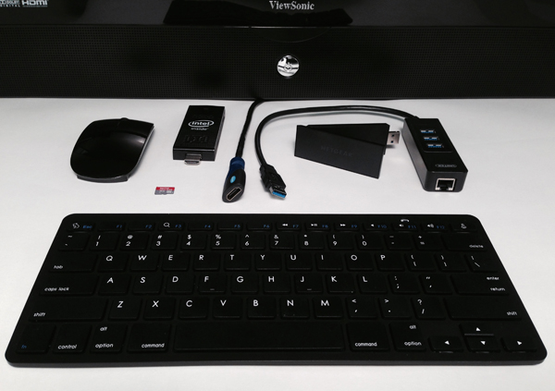

## Figure 3.5 Intel Compute Stick Additional Accessories(REF : <http://www.tomshardware.com/reviews/intel-compute-stick,4126.html>)

Since you may want to keep the Compute Stick's single USB port available, using a Bluetooth keyboard and mouse is probably worthwhile. You get to take advantage of the Compute Stick's wireless tech as you can sit across the room and use the computer without having cables dangling across the floor. In the event that you can't use a Bluetooth keyboard and mouse, getting a wireless USB keyboard with a trackpad might come in handy, especially for couch surfing.

Another item for the Compute Stick wish-list is a powered USB hub to expand the device's usability, especially for items running over 500ma. Since the Compute Stick only uses USB 2.0, getting an equally fast hub would be inexpensive. The hub, though slower than USB 3.0, could be used for items like USB card readers, keyboard, mouse, or webcam. And if the built-in wireless network speeds don't work out for you, consider getting a wired USB NIC or a faster USB Wi-Fi adapter to speed things up.

## III.5. Intel Compute Stick Advantages

It is important for customers and business owners that want to get the Compute Stick to consider whether it fits with their business strategy and are willing to go through the process of putting it together and tailoring the product to their own needs. The benefits that this products offers are

**III.5.1. Transforms any HDMI display into a fully functional computer.**

The Intel Compute Stick is a new generation of computing that transforms any HDMI display into a fully functional computer. It is a power-efficient device that is just four inches long, yet packs the power and reliability of a quad-core Intel® Atom™ processor, with built-in wireless connectivity, on-board storage, and a micro SD card slot for additional storage. It’s everything you love about your desktop computer in a device that fits in the palm of your hand.

**III.5.2. Compute Stick can be used in homes, office, manufacturing lines or any business Environment.**

**III.5.2.1. For Consumers or Home users**

A solution with plenty of storage and performance needed for light productivity, social networking, web browsing, and streaming media, or games.

With built-in wireless connectivity, on-board storage, and a micro SD card slot for additional storage. It’s everything you love about your desktop computer in a device that fits in the palm of your hand.

**III.5.2.2. For Business Users**

Enable solutions for small to medium sized businesses, delivering ultra portability and reliable plug-and-play simplicity, with Windows Remote Desktop access for on the fly support.

**III.5.3. A Great medium for Education purposes.**

Intel Compute Stick has many chances in the field of Education. It is generally for aimed for the younger generation to help in their learning and studying. Programming, Presentation, Collecting data from Internet etc.

**III.5.4. Small size and very cost effective.**

With the low price and small size it is easy for the buyers to cache, so that it can be deployed in large numbers in underdeveloped and developing countries like Africa, India, China, Brazil etc. to schools and colleges and to everyone who is interested in computers and electronics.

**III.5.5. Run your favourite Software and Applications—just as you would on today’s traditional full-sized computers.**

It comes with an Intel Atom 1.33GHz quad core processor, 2GB of RAM and 32GB internal storage, running either Windows 8.1 or Linux. Because of the Intel powered processors all the applications are run smoothly and flawlessly.

Perform more than one task does not affect neither the performance nor the speed of the computer.

**III.5.6. Serious work can be done in small spaces.**

Small form factor provides good processing power and efficiency so we can run

serious task in any place.

**III.5.7. It can be used as a machine replacing desktop computers.**

It is a great solution against the large desktop computers, compute stick perform all

tasks that a desktop system runs. With the low price and small size it is easy for the buyers to cache.

**III.5.8. Solution for mobile employees.**

Only need public monitors in the office. Great security and cost saving on office space

and computer equipment for mobile employees

**III.5.9. Micro SD slot for extra storage.**

A micro SD slot allows you to expand additional storage if you're interested in expanding the storage capacity of the stick Intel provides a micro SD card slot with the capacity of 128 GB.

**III.5.10. Energy efficient Processor**

Intel uses powerful energy efficient processors in compute stick. Mini PCs using a power supply rated at 75 percent2 less wattage than average full size desktop towers free your budgets for other priorities. The product is energy efficient and provides a greener ethical alternative to small businesses.

## III.6. Intel Compute Stick Disadvantages

**III.6.1. Does not useful for large Business.**

This product will not be a great useful for bigger businesses that already have big servers, which would already do everything that the Compute stick does, so it would not be worth it to take the time to get someone to put it together.

**III.6.2. One or two USB ports just aren’t enough.**

The only foreseeable issue with the Stick is the single USB port. One or two USB ports just aren’t enough. If you’re using the Stick as a traditional desktop, you need a port for a mouse and another for a keyboard. You can solve this by attaching a USB hub, but that’d almost certainly compromise the stick-on-the-back-of-the-TV form factor, assuming it didn’t weigh down the Stick jutting out of the TV’s HDMI port in the first place. A keyboard with a USB pass-through would work, but then you’d not only be limited in your peripheral choices, but wouldn’t have another USB port for anything else.

**III.6.3 No slot for USB 3.0/3.1**

Faster USB 3.0/3.1 connectivity and more technology that will make the stick PC format attractive to some professionals.

**III.6.4 Powered with a micro USB cord.**

Compute stick does not charged when it is plugged into a HDMI port it is charged with a micro USB cord.